Graphic representation of the Cube :

Considering the program has to take an unresolved cube and outputs the solution, we have decided to divide the graphical aspect into two different sections: input and output. The input mechanism is used so that the user can input each color individually on the cube's surface, whereas the output will show each move using arrows and then execute the move to prepare the cube for the next move.

Input

A Rubik's Cube consists of, in fact, 26 smaller 'cubies' as oposed to 54 colored stickers; this means that when a move is executed, there are 8 cubies that rotate around the central cubie. As illustrated in the image on the right.  As shown, the yellow, red, and blue axes (each colored by the central cubie of that face) do not move, only the up “U” face has turned counterclockwise “U'”. Subsequently, the orange and two yellow stickers on the blue, frontal face “F” in the first image end up in the same order on the red, right face “R”. | 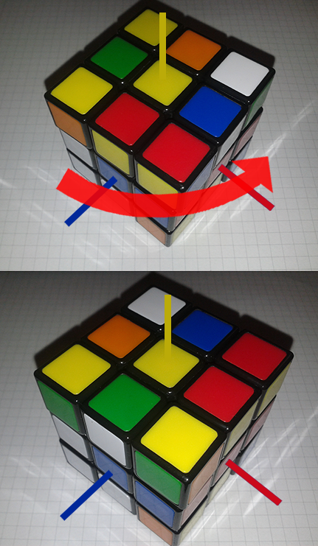

Since the axes don't move that means that of the 26 cubies, the central ones don't move, which leaves us with 20 cubies (because there are 6 faces to a cube) that can move. Furthermore, these 20 cubies can be separated into two groups: corners and edges. Corners have three different colors and edges have two different colors, and each one of these cubies are unique. This means that we will have to handle the user's inputs in order for them to be possible; there can only be one blue-red edge like there can only be one yellow-green-orange cubie.

We have done some research on the internet and have found many Cube solving programs, but the one that has the simplest input interface uses a T-shaped layout. The user will be able to click on a square and input the color they desire, within the limitations discussed in the previous paragraph. On the following image is a screenshot of said interface.

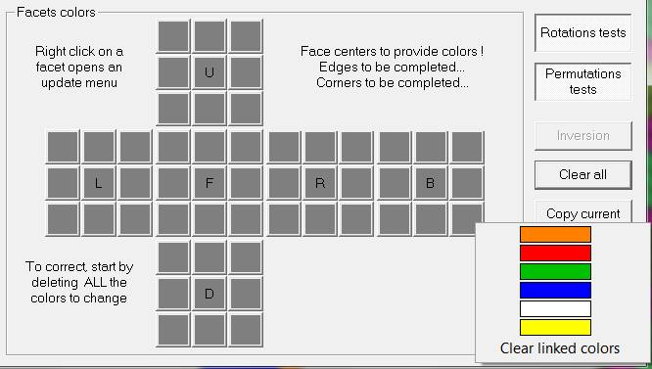
This T-shape represents the cube in two dimensions where L,F,R,B,U, and D represent the faces on the user's Left, Front, Right, Back, Up, and Down respectively. The contextual menu with the six colors apears when the user right clicks on a square and they can select the color that is availabl for that square; if the red-blue edge already exists, the only other combination of colors for edge cubies associated to the red color are red-green, red-white, and red-yellow because the adjactent faces to the red face are blue, green, white, and yellow. So, the menu will contain only the remaining possible colors.

Output

The program will then take the state of the cube and the algorithm (look at the Algorithm section) will solve and output the set of moves. These moves will then be shown one after the other on the graphical interface. Now, as the input isn't very representative of a 3D cube, and as we have decided not to use three dimentional graphics, we had to find a compromise of both dimentions.

The first idea we came up with is using isometry. “Isometric” refers to some form of parallel projection where the viewpoint is rotated slightly to reveal other facets of the game environment than are visible from a top-down perspective or side view, thereby producing a three-dimentional effect. As defined by wikipedia, but it is simpler to say that an isometric view is a projection of a three dimentional object on a two dimentional plane. | 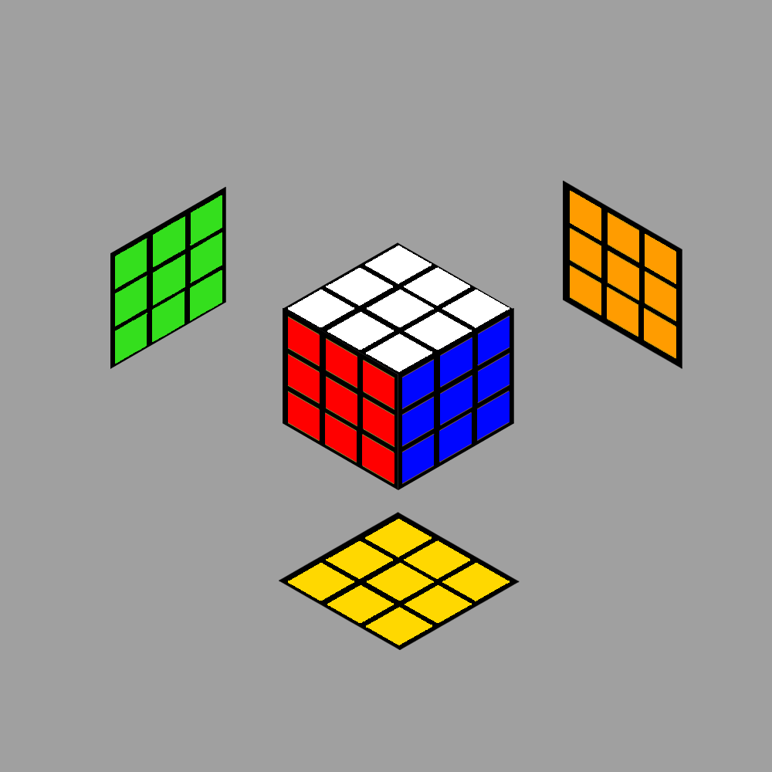

The second idea was to show the desired face of a cube, that means there is no 3D or a resemblance to a 3D cube. The user would be able to rotate and show the face they would like to see. | 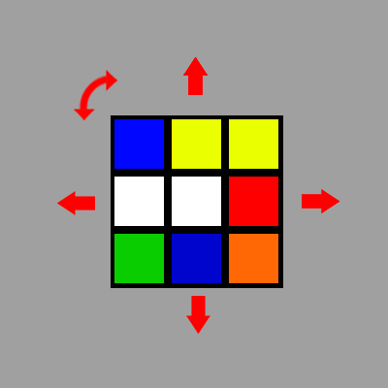

Both these solutions have a problem though; holding a cube in your hand makes it very easy to look at any face of the cube and navigating through the cube to properly see each face is quite problematic when working in two dimentions-- there will always be three or more faces that you cannot see. Working with transparency could be a solution but the problem with that is that it can confuse the user more than it will help.

So, we are considering working with isometry. It makes more sense to work like that because the user will understand very well how to hold the cube in his hand with respect to the image the program is outputting.

The Algorithm

Intro

The cube resolution algorithm we are going to implement was invented by Jessica Fridrich because its the favorited algorithm by most “speed cubers” (people who spend attrocious amounts of time learning to resolve cubes as fast as possible) for its incredible efficiency and its moderate difficulty to learn. The main problem with this algorithm is that it requires to know a lot of different sequences of moves that are difficult to master. Thankfully, computers can handle this “knowledge” and shouldn't be an issue for our program.

Notation

First, we have to define a precise notation for the moves on the cube. There already exists a standard notation used by mathematicians and people who study the cube and there is no need to re-invent the wheel, so we will use that notation.

In Short:

Moves are defined by the initials of the face it has to be executed in. For instance, the move U means that the Up face (relative to the way the cube is held) has to turn a quarter turn clockwise, and the move U' is a counter-clockwise turn of the Up face. Furthermore, the U2 move represents two clockwise quarter turn moves of the Up face.

Moves

To handle the sequences of moves the program will have methods that take as parameters a string withholding the list of moves. This means that we will have to code a decoder so that a string containing “F U R U' R' F'” actually performs the correct set of moves: F followed by U, followed by R, followed by etc. We will also implement each move individually, as there are only 18 possible moves on a cube {F, F', F2, U, U', U2, R, R', R2, L, L', L2, D, D', D2, B, B', B2} and considering FURLDB(2) are simply FURLDB launched twice, then there really only are 12 moves to code.

How it works

This section explains the Fridrich algorithm, how it works, and how we will implement it.

- Step 1 – Creating the bottom layer “cross”
  - Find the 4 edge cubies that belong to the bottom layer
  - Move them to the bottom layer in the correct orientation

- Step 2 – First two layers (F2L)
  - Find the 4 bottom layer cubies and their corresponding edge cubies
  - Move them in the correct position

- Step 3 – Orienting the last layer (OLL)
  - Determine the color of the upper layer
  - Move and orient all the cubies to have their corresponding color facing the upper layer

- Step 4 – Positioning the last layer (PLL)
  - Move the cubies to their correct location

Representation

There is one last point to talk about in this section which is how the program will implement the cube. We have opted for an object system whereby the class Cube will have as child the class Cubie. The cube class will contain 26 cubies and their position, whereas the Cubie class will contain the one, two, or three colors assigned to the cubie and it's orientation. Now, the orientation of the cubie will have to be handled carefully because when a move is executed, the cubie has to be facing the direction it should be facing as it would on a real cube.

Cube

Cubie

Edge

Edge Cubies are slightly easier to handle because they can have only two possible orientation-- the first color on the right or on the left of the face it is in. As the position of the cubie is determined by the parent class, it is always known and therefore the orientation is relative to the position.

Corner

